This project is generously funded by [NSF iTEST](https://www.nsf.gov/awardsearch/showAward?AWD_ID=1901704&HistoricalAwards=false). Spatial skills are defined as the ability to perceive, retrieve, visualize, and mentally transform the static and dynamic visual information of objects and their relationships. This ability helps people to abstract key visual and spatial information from distracting backgrounds, to transform 2D information into 3D or vice versa, to navigate a given environment or to visualize a new setting. Research shows that spatial skills are important predictors of long-term achievement and attainment in Science, Technology, Engineering, and Mathematics (STEM). Computational thinking refers to the thought processes in expressing solutions as computational steps or algorithms that can be carried out by an information-processing unit, or computer. Computational thinking often involves the practices of extracting the essence of a complex problem (abstraction), dissecting the problem into manageable and functional parts (decomposition), and designing and evaluating logical and ordered instructions for rendering a solution to the problem (automation and analysis). We bring together a team of scientists, educational technologists, and career development experts for this project to create an innovative learning experience and suitable technologies to foster upper elementary school Latinx students’ spatial computational thinking skills, as well as to raise upper elementary school Latinx students’ awareness of computationally-intensive careers, and interest and self-efficacies in computing and engineering.

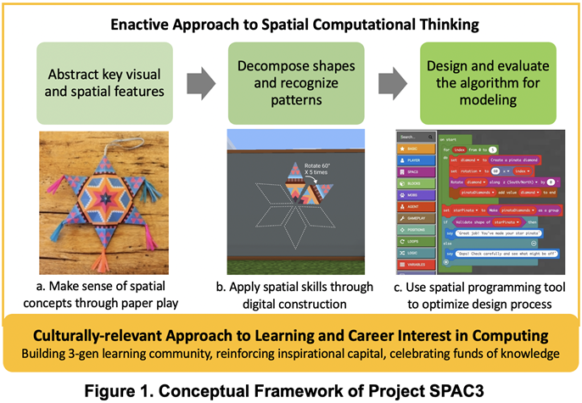

**Example of using the SPAC3 module for 3D modeling and validating**

Publications:

Check out later.